Data Briefing
September 2013

EYE HEALTH – BASELINE EVIDENCE AND SERVICE DATA

Note : This document is adapted from the RNIB’s ‘Joint Strategic Needs Assessment (JSNA) template and guidance’ RNIB (2012), enhanced with available information on the local prevalence of the most common eye conditions.

This briefing focusses on identifying and quantifying conditions; a detailed health needs assessment which also examines current service provision in West Sussex will be undertaken at a later date.

Drafted by
Roy Marsh
West Sussex Public Health Research Unit
September 2013

CONTENTS

1 Summary 3
2 Overview of eye conditions 6
2.1 Glaucoma 6
2.2 Cataracts 6
2.3 Age-related macular degeneration (AMD) 6
2.4 Diabetic retinopathy (DR) 6
3 Defining and measuring visual impairment 7
4 Prevalence of eye conditions 9
4.1 Prevalence of sight loss in West Sussex (RNIB) 9
4.2 Prevalence of sight loss in the UK (Future Sight Loss UK) 9
4.3 Predicted prevalence in the UK (Future Sight Loss UK) 10
4.4 Estimated Prevalence in West Sussex (National Eye Health Epidemiological Model) 12
4.5 Predicted prevalence in West Sussex, by age and impairment (POPPI and PANSI) 15
4.6 Ethnicity and visual impairment in the UK and West Sussex 15
4.7 Associated health conditions 17
4.8 Socio-demographic and life-style factors 18
4.9 Estimated prevalence of visual impairment in children 19
5 Sight Tests, Ophthalmic Practitioners and Cataract Removal 21
5.1 NHS sight tests - general 21
5.2 NHS sight tests – by service-user group 22
5.3 Ophthalmic Practitioners 22
5.4 Secondary care / Hospital Episodes Statistics (HES) 23
6 Outcomes indicators 24
6.1 Registered sight loss – the Certificate of Vision Impairment 24
6.2 CVI registration and the Public Health Outcomes Framework 26
7 Costs 28
8 References 29

Summary

Why sight loss is important

- Sight loss affects many people.

- Sight loss is increasing.

- Sight loss is costly to the health services and to the country.

- Sight loss affects some ethnic and socio-demographic groups more than others.

- Some sight loss is preventable if identified and treated early enough.

Prevalence and Trends

- There are 1.86 million people in the UK living with sight loss. By 2020 this number is predicted to increase by 22 per cent and will double to almost four million people by the year 2050 (1).

- The increase can be attributed chiefly to an ageing population; over 80 per cent of sight loss occurs in people aged over 60 years (1).

- Eye conditions are projected to increase greatly over the coming decades, in line with population increases and an ageing population.

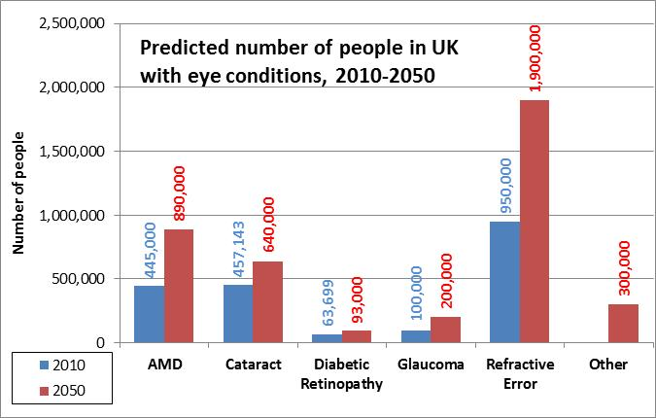

- In West Sussex the prevalence of visual impairment (moderate and severe sight loss) ranges from 4% to 6% of the population, with the highest prevalence in Worthing. Due to its greater population, the number of people with visual impairment is greatest in Arun.

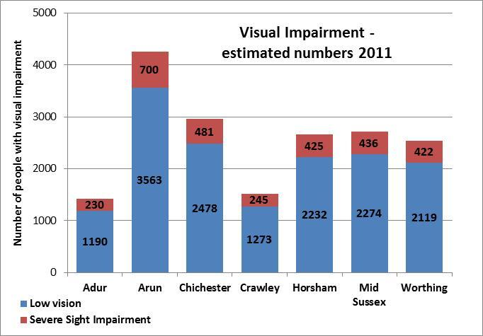
Source: NEHEM. Refers to age 50+ years

Service Demand and Costs

- Ophthalmology had the second highest attendances among hospital departments, 2010-11 (2).

- The RNIB have estimated that half of all falls are due in part to visual impairment.

- Nationally, in 2008, the direct and indirect cost of sight loss was estimated £6.5 billion and by 2013 these costs will rise to £7.9 billion (1). The direct cost to the NHS of vision problems in the UK has been calculated at £40,900 per 1,000 people, with a total cost of £2.14 billion.
Source: RNIB / FSUK (3)

Conditions, Causes and Associations

- Visual impairment (sight loss not due to correctable refractive error) is mainly linked to four conditions – Age-Related Macular Degeneration (AMD), cataract, glaucoma and Diabetic Retinopathy (DR).

- Visual impairment is associated with social, environmental and lifestyle factors, including smoking and obesity.

- Visual impairment is also associated with socio-economic deprivation.

- Some types of visual impairment are caused by chronic health conditions. For example, diabetic retinopathy is a symptom of diabetes. Regular sight tests support detection.

- Adults with learning disabilities are 10 times more likely to be blind or partially sighted than the general population.

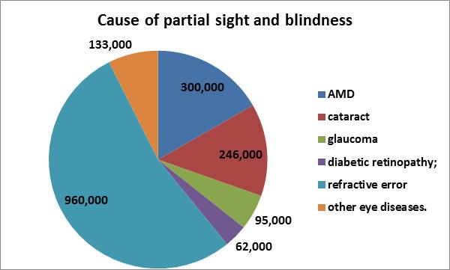

Causes of sight loss
Source: RNIB / FSUK

Ethnicity

- Black people have a greater risk of developing age-related macular degeneration (AMD) compared to white people in younger age groups, whereas white people have greater risk of developing AMD later in life.

- Black people have more than double the risk of other ethnic groups of developing glaucoma.

- Asian people are at lower risk than white people of AMD.

- With 20% of its population belonging to an ethnic minority, Crawley is the only district in West Sussex in which ethnicity is a potentially significant factor in visual impairment. The actual numbers at risk are low, however, since the ethnic age profile is younger.

Children

- There are estimated to be 10-20 visually impaired children per 10,000 children.

- Children tend to have slight visual impairment, or severe visual impairment associated with other disabilities.

- There is an increased rate of severe sight problems and blindness in children from ethnic minorities. This may be linked to socio-economic deprivation.

- There has been a decline in the incidence of treatable or preventable disorders such as retinopathy of prematurity and congenital cataract, due to better primary prevention, early detection and medical and surgical management.

- There has, however, been an increase in untreatable disorders such as cerebral sight problems, inherited retinal dystrophies, optic nerve atrophy and hypoplasia. This is in part due to the increased survival of premature and very low birth weight babies and children with major anomalies, complex and malignant disease.

Source: ‘Disability Needs Assessment.’ The Child & Maternal Health Intelligence Network

Overview of eye conditions

Half of all sight loss is caused by refractive error, which can generally be corrected with glasses or contact lenses and will not be considered further here. The most common conditions needing intervention beyond simple corrective measures are summarised below.

Glaucoma
This is a group of eye conditions in which the optic nerve is damaged due to changes in eye pressure. Damage to sight can usually be minimised by early diagnosis and treatment.

Cataracts
This is a common eye condition that is prevalent in older people. The lens becomes less transparent and turns misty or cloudy. Cataracts over time can get worse and affect vision. A short routine operation replaces the lens with an artificial one.

Most cataracts are age-related and cause no physical harm to the eye. The decision to offer cataract surgery is typically dependent on the degree to which the cataract is affecting a patient’s quality of life and how much they want it removed. A simple visual acuity test will not detect inconvenience due to glare, colour rendition and low contrast. This variability, along with the gradual nature of onset, has led to wide variations in estimates of prevalence. Patient-centred care and support is crucial.(6)

Age-related macular degeneration (AMD)
This condition commonly affects people over the age of 50 and is the leading cause of blindness in people over the age of 65. There are two main types of AMD: neovascular or exudative AMD commonly known as wet AMD; and atrophic commonly known as dry AMD.

- Wet AMD can develop quickly affecting central vision in a short period of time. Early identification and treatment of wet AMD is vital. Treatment can halt the further development of scarring but lost sight cannot be restored. There are several drugs available, with a lively debate about their comparative cost-effectiveness (reference).

- Dry AMD is more common. It can develop slowly and there is currently no treatment. In “early AMD, small yellow deposits called drusen form under the macula.

Diabetic retinopathy (DR)

DR is a complication of diabetes mellitus, usually affecting both eyes, It has no early symptoms and can lead to permanent sight loss. Early diagnosis and treatment can prevent up to 98 per cent of severe vision loss and the earlier treatment is received the more likely it is to be effective.

Defining and measuring visual impairment

- Visual impairment is sight loss that cannot be corrected using glasses or contact lenses (NHS).
- Low vision is sight loss which can often be improved with aids and adaptations.

This report focuses on visual impairment.

There are broadly three approaches to defining visual impairment: (1) functional, referring to the ability to carry out daily activities, (2) visual capacity, referring to the degree of impairment, (3) clinical, referring to the associated medical condition. A range of terms is used to describe the degree of visual impairment, with usage varying somewhat between sources, and the same term often being used in both a functional and a capacity sense. Terms therefore need to be interpreted carefully in context. Purely functional definitions of visual impairment are:

- Sight impairment: ‘substantially and permanently handicapped by defective vision caused by congenital (present at birth) defect, illness or injury.’
- Severe sight impairment: ‘so blind as to be unable to perform any work for which eyesight is essential.’
Source: DWP.
http://www.dwp.gov.uk/publications/specialist-guides/medical-conditions/childrens-medical-guides/visual-impairment/other-factors/registration-of-visual-impairment.shtml

’Sight impairment’ is broken down further into partial sight and moderate sight, while ‘Severe sight impairment’ includes blindness. These can be defined

Capacity-based definitions represent the degree of visual impairment using a combination of Visual Acuity (VA) and Field of Vision. A VA assessment of 6/60 means that the assessed person can only see at 6 metres what a ‘normal’ person can see at 60 metres. Thus a VA of 6/6 is a ‘normal’ assessment. The table below summarises.

Category | Visual Acuity | Field of Vision
Partial sight impairment | Very poor (3/60 to 6/60) | Full
 | Moderate (up to 6/24) | Blurriness or cloudiness in central vision or reduced field of vision
 | Relatively good (up to 6/18) | Much of field of vision missing
Severe sight impairment (incl. blindness) | Extremely poor (less than 3/60) | Full
 | Poor (between 3/60 and 6/60) | Severe reduction
 | Average (6/60 or better) | Severe reduction
Source: NHS Choices
http://www.nhs.uk/Conditions/Visual-impairment/Pages/Introduction.aspx

The VA is important for health and social services, since a VA of less than 6/18 is used as a guideline threshold for registration as severely sight impaired (including blind) or as sight impaired (partially sighted), thereby giving entitlement to certain health services and benefits. The VA assessment also helps when comparing information from different sources.

WHO break ‘Severe sight impairment’ down further:

- Blindness is defined as visual acuity of less than 3/60 (0.05) or corresponding visual field loss in the better eye with best possible correction. (ICD-10 Codes 3, 4, & 5)
- Low Vision corresponds to visual acuity of less than 6/18 (0.3) but equal to or better than 3/60 in the better eye with best correction. (ICD-10 Codes 1 & 2)

http://www.who.int/mediacentre/factsheets/fs282/en/index.htm

Note on ‘low vision.’ In the RNIB JSNA template, the term ‘Low Vision’ is used to mean ‘sight loss that is not registerable and yet not correctable by spectacles.’ This is different from both the WHO definition and the definition cited at the beginning of this report‘, so the RNIB usage is perhaps best thought of as ‘mild sight loss’, referring to a VA of between 6/12 and 6/18, and indeed it is used as such the FSUK report (below).

Note on functional definitions. There is no single definition or description as to what the various degrees of visual capacity mean in functional terms. So it is not obvious, for example, how ‘mild sight loss’ affects the activities of daily living, and thereby what specific support needs might be, from carers and the social or health services.

Clinical definitions

The codes of the International Statistical Classification of Diseases are used in certain datasets that contain clinical information – for example, Hospital Episode Statistics – and are useful in linking data from different service sectors, and in identifying the potential impact of visual impairment on service use.

ICD Group H covers ‘Diseases of the Eye and Adnexa,’ with blocks of codes for conditions related to the retina, cornea, cataract, etc. Codes beginning H54 are specifically related to visual capacity, such as H541 ‘BLINDNESS, ONE EYE, LOW VISION OTHER EYE.’ However, the codes do not define vision in clinical or functional / behavioural terms.

There are blocks of code in other groups that bear upon eye conditions, for example in the Groups ‘Neoplasms’ (C692 ‘MALIGNANT NEOPLASM OF RETINA’), Group ‘Nutritional deficiencies’ (E502 ‘VITAMIN A DEFICIENCY WITH CORNEAL XEROSIS’), Group ‘Congenital Malformations, Deformations and Chromosomal Abnormalities’ (Q120 ‘CONGENITAL CATARACT’) and Group ‘Others’ (Z973 ‘PRESENCE OF SPECTACLES AND CONTACT LENSES’).

Note on ICD codes: WHO has pointed out some shortcomings in the ICD coding of blindness and suggested some coding changes. Of specific interest to the public health and social services:

Nomenclature
‘persons who would benefit from low vision care also exist among those who are currently categorized (under ICD) as blind. This has led to miscalculations in the estimation of persons requiring low vision care.’

Blindness
‘The current definition does not make a distinction between those who have “irreversible” blindness (NO perception of light) and those that have light perception but are still less than 3/60 in the better eye. The management of these two categories is different and categorization based on this would be useful.’

http://www.who.int/blindness/Change%20the%20Definition%20of%20Blindness.pdf

Prevalence of eye conditions

Estimates of current and projected prevalence of the sight loss due to the various conditions were obtained from several sources. Some sources break their estimates down by age, gender and ethnicity.

Prevalence of sight loss in West Sussex (RNIB)

The RNIB’s ‘Sight Loss Data Tool’ summarises various estimates of the prevalence of visual impairment, at different degrees of severity, at county level. Their estimate of ‘sight loss’ provides an entry-point into the more detailed estimates given in the following sections. ‘Sight loss’ is defined as best-corrected visual acuity of <6/12 or worse in the better-seeing eye, which is at the more moderate end of the visual impairment spectrum.

- Reflecting population age structure, West Sussex has a greater proportion of people with sight loss (at 3.78%) than the South East region (3.15%) or England (2.95%).
- This relative difference will persist through to 2020

http://www.rnib.org.uk/aboutus/Research/statistics/Pages/sight-loss-data-tool.aspx )

Prevalence of sight loss in the UK (Future Sight Loss UK)

Extensive modelling of the estimated and predicted prevalence and the costs of visual impairment at UK level was carried out by Access Economics, a consultancy, on behalf of the RNIB in 2008. Many permutations of age, severity, gender and ethnic group were taken into consideration. The estimates were made for the adult population of the whole UK.

For the base year 2008, FSUK estimates were as follows:

- 1.8 million people had partial sight and blindness.
- 1.13 million (63 per cent) were female and 664,000 (37 per cent) were male.
- Half of all sight loss was due to refractive error, correctable by glasses. The other half was due to four main conditions, largely AMD and cataract

Causes of partial sight and blindness
Source: FSUK

Predicted prevalence in the UK (Future Sight Loss UK)

FSUK predicts a steady increase in prevalence of moderate to severe eye conditions to the year 2050. The rate of increase will be greatest for AMD, such that the percentage (the ‘share’) of people with eye conditions that have diabetic retinopathy will actually decrease in comparison.(3)

UK Numbers | Year 2010 | Year 2050
AMD | 445,000 | 890,000
Cataract | 457,000 | 640,000
DR | 64,000 | 93,000
Glaucoma | 100,000 | 200,000
RE | 950,000 | 1,900,000
Other | NA | 300,000
Predicted change in number of people with moderate and severe eye impairment
Source: FSUK

Predicted numbers of people with eye conditions to 2050
Source: FSUK

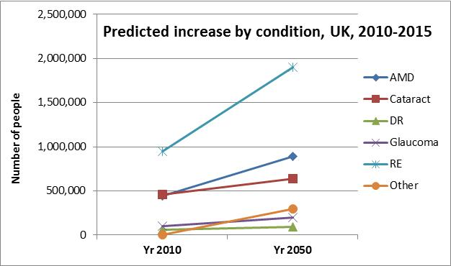
Predicted increase in sight loss by condition to 2050
Source: FSUK

Women make up a greater proportion of the population with eye conditions than men, due to their greater life expectancy. This gender difference will continue through to 2050. However, the life expectancy gap is narrowing.

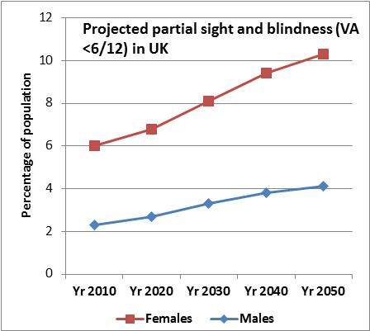
Percentage of the male/female population with partial sight and blindness, projected till 2050.
Source: FSUK

Estimated Prevalence in West Sussex (National Eye Health Epidemiological Model)

The National Eye Health Epidemiological Model (NEHEM) is ‘based on prevalence rates derived from epidemiological population surveys.’ Drawing from a number of epidemiological studies, the NEHEM model calculated (in 2008) the prevalence of the common eye conditions, for various permutations of age, ethnicity and gender.

In order to provide estimated actual numbers, the NEHEM prevalence rates have been applied to West Sussex population figures taken from the 2011 Census. That is, it is assumed that the (best estimates for) prevalence in 2008 are still valid for 2011.

Note: NEHEM definitions

- Severe sight impairment < 3/60 (i.e. ‘blind’)
- Low vision < 6/18 to 3/60 (i.e. sight impairment falling short of blindness)
- Visual impairment the above two categories combined

So NEHM’s ‘Low Vision’ category is the threshold level for registration as sight-impaired.
http://www.eyehealthmodel.org.uk/MainApplication/Default.aspx#basePrevalencesAnchor
www.eyehealthmodel.org.uk

Cataract

The NEHEM model estimates the prevalence of surgical cataracts, i.e. cataracts which were affecting the patient’s vision sufficiently to consider surgery. This model provides two estimates, a high and low, based on two population prevalence studies (McCarty et al, 1999 and Frost et al, 2001), shown below. The wide gap between high and low estimates may reflect the subjective nature of perceived cataract impairment and the differences in ways of diagnosing cataract.

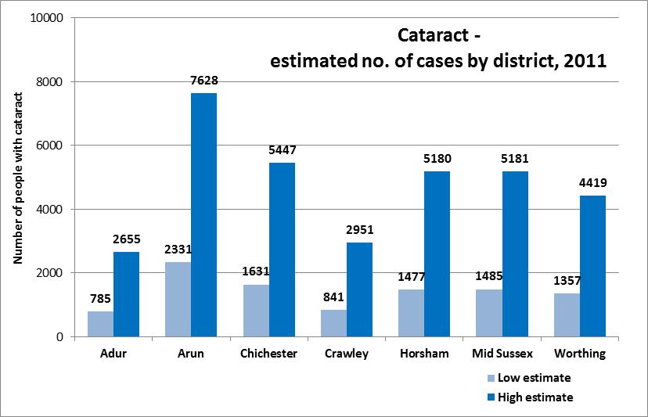
Cataract – estimated number of cases by district, 2011
Source: NEHEM

Age-Related Macular Degeneration (AMD)

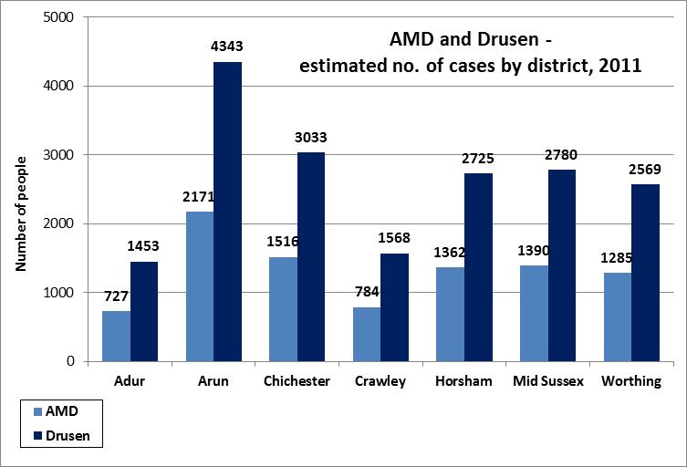
AMD and Drusen - estimated no. of cases by district, 2011
Source: NEHEM

Note: Drusen.
In early AMD, small yellow deposits called drusen form under the macula. The AMD estimates given here are separate from the Drusen estimates. NEHEM model the ‘soft distinct drusen of a uniform density with sharp edges’ and not the ‘isolated hard drusen in the absence of any other features [characteristic of AMD].’

Low Vision and Severe Sight Impairment

(N.B. the NEHEM definitions: Visual Impairment = Low Vision + Severe Sight Impairment.)

The district with the highest prevalence (percentage of the population) with Low Vision and Severe Sight Impairment is Worthing. However, due to its greater population, the district with the greatest number of people with Low Vision is Arun.

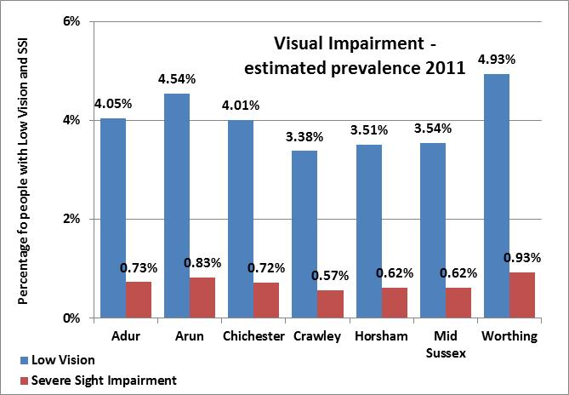
Visual Impairment – estimated prevalence, 2011
Source: NEHEM

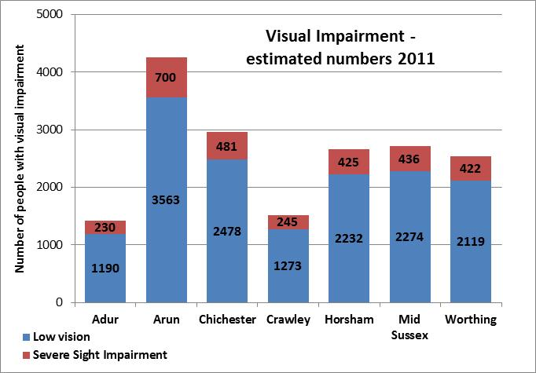
Visual Impairment – estimated numbers, 2011
Source: NEHEM

Predicted prevalence in West Sussex, by age and impairment (POPPI and PANSI)

Age-specific predictions for various degrees of visual impairment are given in two databases provided by the Institute of Public Care. PANSI describes the 18-65 years population, while POPPI includes people 65 years and older.

For age 75+ years, POPPI uses the following prevalence assumptions (21).

- 5.6% of the age group 65-74 years has moderate or severe sight impairment.
- 12.4% of the age group 75+ years has moderate or severe sight impairment.
- 6.4% of the age group 75 years has moderate or severe sight impairment, but without cataracts or correctable sight loss (though this figure includes a small proportion with cataracts and some other registerable cause of vision impairment).
Source: RNIB
http://www.poppi.org.uk/index.php?pageNo=341&PHPSESSID=sv99oeefsa7c1vt3k6r69qr933&sc=1&loc=8640&np=1

For age 18-64 years, based on a 2005 literature review and two other sources, PANSI use the take 0.065% as an estimate of the numbers of people in the 18-64 years age group with a severe visual impairment. http://www.pansi.org.uk/index.php?pageNo=398&PHPSESSID=mar2egsu6mqccr2aggo5p62br0&sc=1&loc=8640&np=1

N.B. PANSI do not give predictions for moderate visual impairment in this age group, since they consider the variability in the estimates to be too wide to be useful.

For both databases, predicted numbers are derived from applying prevalence rates to ONS population projections in the relevant age group, as below.

 | PANSI / severe | POPPI / moderate & severe
 | Less than 65 yrs | Age 65-74yrs | Age 75+ yrs
2012 | 310 | 4,922 | 10,726
2014 | 312 | 5,275 | 11,086
2016 | 316 | 5,538 | 11,396
2018 | 320 | 5,673 | 11,978
2020 | 323 | 5,723 | 12,784

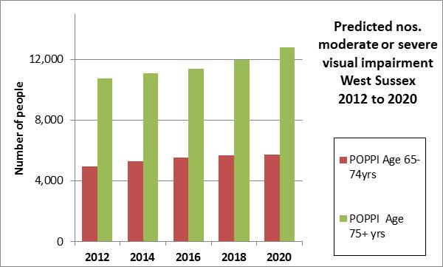
Predicted number of people with moderate or severe visual impairment
Sources:POPPI

Ethnicity and visual impairment in the UK and West Sussex

Ethnicity is a factor in some forms of visual impairment. Unfortunately, most studies of minority ethnic groups and their health in the UK have not collected data about partial sight and blindness. (Johnson and Scase, 2000). Two studies were found which have nevertheless made a rigorous attempt to synthesis available information and quantify the relative risk of different ethnic groups to the common eye diseases (NEHEM and FSUK). To summarise what is known:
Glaucoma

- Black people have four times greater risk of glaucoma than white people – a difference which is also borne out in American studies. (Wormald et al, 1994), (3).
- People from South-East Asia and China are at higher risk of angle-closure glaucoma (8).

Cataracts

- Asian people have a higher risk of developing cataracts than black and white people (Kempen et al 2004; Das et al 1994).
- The much higher prevalence of cataract in Asian people aged less than 60 years suggests an earlier onset of the disease.

Diabetic eye disease

- African, African Caribbean and Asian people are at a higher risk of developing diabetic eye disease, compared to white people (Kempen et al 2004; Das et al 1994). (1).

AMD

- Black people have a greater risk of developing AMD compared to white people in younger age groups, whereas white people have greater risk of developing AMD later in life;
- Asians are at lower risk than white people of AMD (Friedman et al 2004; Das et al 1994).

Refractive error

- White people have a greater risk of developing refractive error than black people (Kempen et al 2004a).

Other eye diseases

- For other eye diseases, no clear ethnic differences in risk have been found (Munier et al 1998; Ghafour et al 1983).

The 2011 Census recorded 807,000 people in West Sussex, of whom 757,000, or 94%, were white. The proportion of ethnic minority groups in each district ranges between 3% and 6%, except in Crawley, where at 20% the ethnic minority proportion is markedly higher. The chart below shows the ethnic minority populations and breakdown in each district. Any ethnicity-related eye conditions will therefore be predominantly found in Crawley.

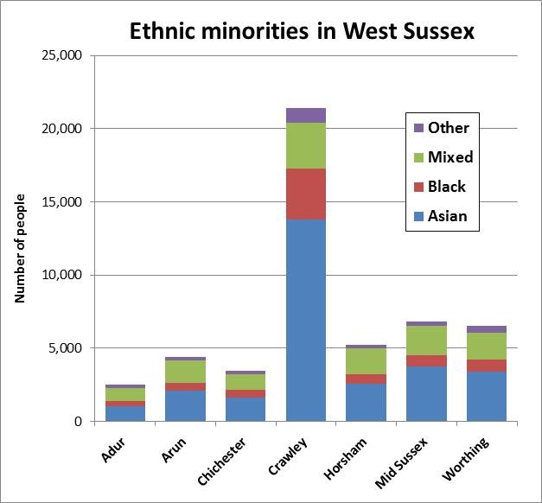

Associated health conditions

Some health conditions are closely associated with sight loss, which compounds the impact on the individual and on the health and social care services.

- About 10% of those registered blind and 10% of the newly-registered partially-sighted in West Sussex were also recorded with an additional disability.

- This is lower than the 33% cited by the HSCIC as the national percentage, and is made up mainly of people aged 65 years and older with a physical disability or who are hard of hearing

Source: HSCIC (20)

The presence of any of the following conditions could nevertheless serve to indicate possible sight loss, and that extra attention to be paid to diagnosis and potential support needs.

Learning disabilities
An estimated 96,500 adults with learning disabilities in the UK, including 42,000 known to the statutory services, are blind or partially sighted. This means that nearly one in ten adults with learning disabilities is blind or partially sighted. Adults with learning disabilities are 10 times more likely to be blind or partially sighted than the general population (10).

Obesity
Obesity has been linked to several eye conditions including cataracts and AMD. Obesity also has a strong link to diabetes and an exacerbation of sight deterioration in diabetic retinopathy (13).

Stroke
Around 60 per cent of stroke survivors have some visual dysfunction following stroke. The most common condition is homonymous hemianopia, a loss of half a person's visual field, which occurs in 30 per cent of all stroke survivors (14).

Blood Pressure /Hypertension
In addition to increasing the risk of stroke, uncontrolled high blood pressure increases the risk of both retinal vein and retinal artery occlusion. Both conditions can cause sudden loss of vision in one eye and can lead to further complications (15).

Dementia
At least 123,000 people in the UK have both dementia and serious sight loss (1). As the population ages an increasing number of people will experience both dementia and sight loss (17).

Depression
Older people with sight loss are almost three times more likely to experience depression than people with good vision. The Royal College of Psychiatrists estimates that 85 per cent of older people with depression receive no help at all from the NHS (18).

Socio-demographic and life-style factors

Socio-economic group
There is a link between people on low incomes and living in deprivation and people living with sight loss; three out of four blind or partially sighted people are living in poverty or on its margins (9).

Smoking
The link between smoking and AMD, the UK's leading cause of blindness, is as strong as the link between smoking and lung cancer. Smokers not only double their risk of developing AMD but also tend to develop it earlier than non-smokers. Furthermore, smoking can make diabetes-related sight problems worse, and has been linked to the development of cataracts (11).

Falls
The RNIB have estimated that ‘almost half (47 per cent) of all falls sustained by blind and partially sighted people were directly attributable to their sight loss.’ The RNIB recommend ‘Scuffham's formula’ for more detailed calculation of the number of falls that can be attributed to sight loss. (17) (22)

Estimated prevalence of visual impairment in children

This is a summary of the relevant sections from a report by the Child and Maternal Health Intelligence Network (CHIMAT). CHIMAT derive their prevalence estimates from a 2005 RNIB (RNIB) review of the literature on visual impairment in the UK in 2005 and other sources (25). www.chimat.org.uk/default.aspx?QN=CHIMAT_LOCAL and www.rnib.org.uk/Pages/Home.aspx

Visual impairment

While noting the variation in terminology, the RNIB nevertheless considered that a broad and pragmatic definition of visual loss (sufficient severity as to mean a child is identified as being in need of special educational or social services) would allow the prevalence of visual impairment to be estimated at 10-20 visually impaired children per 10,000 children.
Data collected from local authority advisory services tend to show prevalence at about 20 children per 10,000. However, a separate source( DCSF), based on the individual pupil data collected from schools finds 10.5 per 10,000 whose primary special educational need is a visual or multi-sensory impairment.

The discrepancy comes from the DCSF only including children whose primary disability is sight problems which means that DCSF data is likely to under-represent the size of the population of pupils with a visual impairment.

Applying both high and low estimates for West Sussex, the overall number of children with a visual impairment is estimated to be between 101 and 197 children, broken down as in the table below.

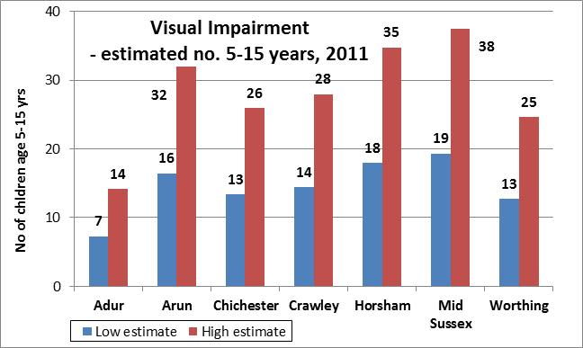
High and low estimates of visual impairment in children in West Sussex, 2011
Source: CHIMAT

Severe visual impairment

A survey-based estimate of the child prevalence of the most severe visual impairment (VA < 6/60 or registered blind) found that

- The annual incidence was highest in the first year of life, at 4 per 10,000,
- The cumulative incidence by 16 years of age was 5.9 per 10,000.

Based on these CHIMAT / RNIB estimates, the number of children with severe impairment or blindness in West Sussex is given in the table below:

At birth | 4
Age 1-4 | 1
Age 5-16 | 7
Age under 16 | 5
Severe visual Impairment estimates 0-15 years old (2011)
Source: CHIMAT

Children - Comorbidity and associations with socio-demographics

A re-analysis of the 1989 Office of Population Censuses and Surveys (OPCS) child disability survey used cluster analysis to group together the children into different groups or clusters according to shared characteristics. The study showed that children were likely to have:

- a mild to moderate visual impairment with few other disabilities,
or
- visual impairments of a more severe nature, along with several other disabilities also of a severe or profound nature. (23)

Rahi and Cable (24) additionally observe that the characteristics of the population of children with severe sight problems or blindness is changing. This is because:
- There has been a decline in the incidence of treatable or preventable disorders such as retinopathy of prematurity and congenital cataract.
- There has been an increase in untreatable disorders such as cerebral sight problems, the inherited retinal dystrophies, optic nerve atrophy and hypoplasia.
- The decline is linked with improvements in primary prevention, early detection and medical and surgical management.
- The increase is linked with changing trends in childhood chronic disease and disability that are themselves linked with increased survival of premature and very low birth weight babies and children with major anomalies, complex neurological and metabolic diseases and malignant disease.
The consequences of these changes are that:
- Proportionally more children with severe sight problems and blindness now have additional - often very complex - disabilities. 77% of children in the study had additional non-ophthalmic disorders or impairments.
- Very premature and low birth weight babies are at particular risk of severe sight problems and blindness.
- There is an increased rate of severe sight problems and blindness in children from ethnic minorities. There is also an association with socio-economic deprivation. These two factors may also be correlated, although with certain ethnic groups where inter-cousin marriages are common, autosomal recessive disorders are found.
The researchers also noted that their finding of a higher than expected proportion of children with additional disabilities reflects partly the changing nature of the population at risk. They speculate that it may also partly reflect the fact that other studies which rely on ophthalmic sources alone under-represent the number of children with additional disabilities.

Sight Tests, Ophthalmic Practitioners and Cataract Removal

West Sussex has higher rate of NHS sight tests than neighbouring counties and UAs in the region. Further work would be needed to ascertain whether this was significantly higher.

NHS sight tests - general

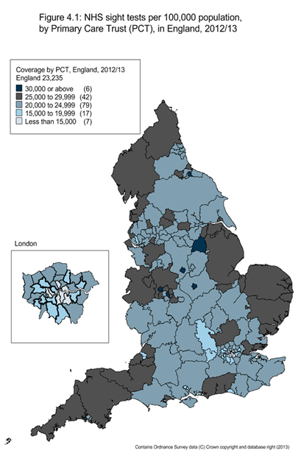

Source: HSCIC
http://www.hscic.gov.uk/searchcatalogue?productid=12003&topics=1%2fPrimary+care+services%2fEye+care+services&sort=Most+recent&size=50&page=1#top Annex A, Figs 4.1 - 4.

NHS sight tests – by service-user group

Data concerning some aspects of service provision the primary care sector is obtainable from the Health and Social Care Information Centre (HSCIC). The pie chart below shows that the three-quarters of all NHS eye tests (i.e. free eye tests) were age-related – children and those aged over 60. The small proportion of NHS eye tests related to purely visual impairment was largely made up of people with glaucoma and their close relatives.

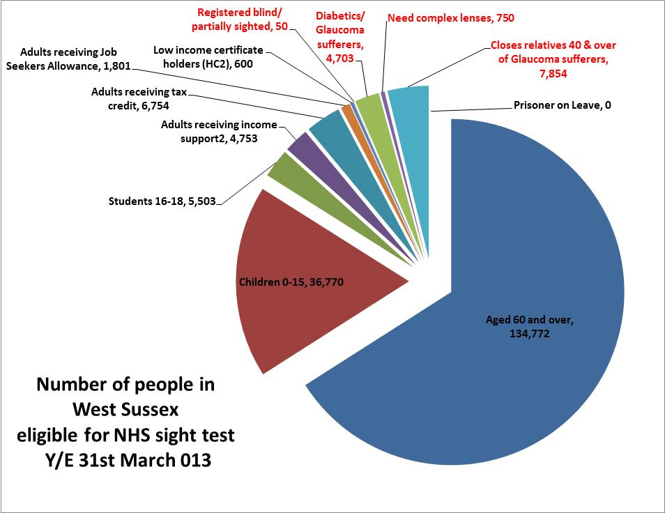

Breakdown of sight tests by type of person / group. Groups eligible by virtue of eye condition are in red.
Source: HSCIC, General Ophthalmic Services: Activity Statistics for England, year ending 31 March 2013
File: HSCIC - gos-act-stats-eng-12-13-anx-b

Ophthalmic Practitioners

General Ophthalmic Services gives a simple breakdown of practitioners at county level. Their interactive Web tool allows West Sussex to be compared with another county or the former SHA, and with England, for the years 2011 and 2012.

Practitioners per 100,00 population
 | Per 100,000 population (2011) | Per 100,000 population (2012) | Change
England | 20.3 | 21.0 | 0.6
SE Coast SHA | 20.1 | 20.2 | 0.1
West Sussex PCT | 18.7 | 17.9 | -0.7

Source: GOS
http://www.ic.nhs.uk/statistics-and-data-collections/primary-care/eye-care/general-ophthalmic-services-activity-statistics-for-england-year-ending-31-march-2011

Secondary care / Hospital Episodes Statistics (HES)

HES contains details of all admissions, outpatients, appointments and A&E attendance at NHS hospitals in England. Some HES data on cataract operations was found on the HSCIC Web site, but not for any other eye conditions. The chart below gives admissions by West Sussex district for 2010-2011 and earlier years are also available. Of the seven districts, only Crawley and Mid-Sussex have cataract admissions similar to national and regional levels. The other five districts are significantly lower.

Note:‘Inpatient’ is not taken to mean ‘overnight stay’ here, the majority of cataract operations are day patients and are included in the chart data.

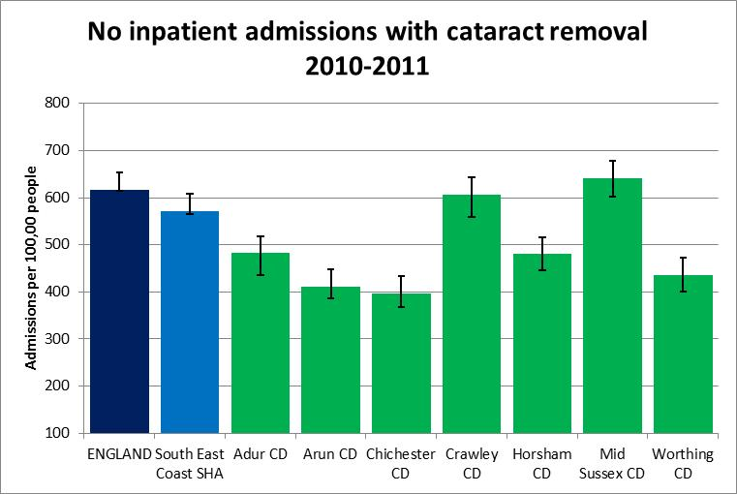

Number of inpatient admissions with cataract removal, 2010-2011 (indirectly age-standardised to 2006-2007)
Source:NCHOD https://indicators.ic.nhs.uk/webview/

Outcomes indicators

Some aspects of health service performance regarding visual impairment are captured through the registration process, and are included in the Public Health Outcomes Framework.

Registered sight loss – the Certificate of Vision Impairment

The Certificate of Vision Impairment (CVI) is used by ophthalmologists to certify a person as either severely sight impaired (blind) or sight impaired (partially sighted).

The formal criterion for registration is a VA assessment of 6/18 or worse. Registration is voluntary, but is a prerequisite for entitlement to certain social services and benefits.

The CVI form consists of three main sections:

- Part 1 is completed by the ophthalmologist to certify the patient as sight impaired or severely sight impaired;
- Part 2 is used to record visual function and the cause of vision impairment;
- Part 3 is completed by eye clinic staff in consultation with the patient to capture epidemiological data.

One copy of the CVI is sent from the hospital to the Certifications Office based at Moorfields Eye Hospital for epidemiological analysis, including data on the main cause of vision impairment. The CVI team is currently funded by the RNIB and the NIHR BMRC for ophthalmology. These copies of CVIs are anonymous. http://ecvi.moorfields.nhs.uk.

Another copy of the CVI is sent from the hospital to local Social Services who contact the individual to offer needs assessment and register the person. This entitles the person to a range of benefits, such as:

- Disability Living Allowance (DLA)
- a 50% reduction in the TV license fee
- tax allowance
- a disabled person’s card

Moorfields Hospital state that there is no diagnostic data in local registers, so they are not usable per se for any more specific analysis or support

Numbers registered blind in West Sussex

- The great majority (~80%) of people registered blind on 31st March 2011 in West Sussex are aged over 75 years.
- The number and beakdown is similar for partially-sighted people, and has changed little in West Sussex since 2006
- This differs from the HSCIC, who report that ‘the trend in the number of people registered blind and partially sighted is falling for those aged over 65 but rising for the younger age groups’(21).

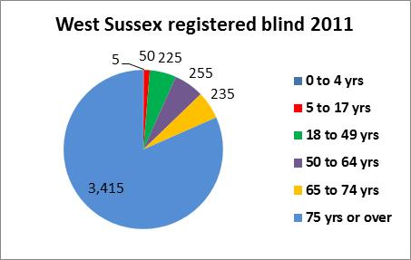

West Sussex  2011 | Age Groups
 | 0 to 4 | 5 to 17 | 18 to 49 | 50 to 64 | 65 to 74 | 75 or over
Blind | 5 | 50 | 225 | 255 | 235 | 3,415
Partially sighted | 5 | 40 | 235 | 180 | 195 | 3,025

Number of blind and partially-sighted people in West Sussex, March 2011.
Source: NHS HSCIC & Moorfields Eye Hospital
http://www.ic.nhs.uk/article/2021/Website-Search?q=registered+blind%2B2006&go=Go&area=both
http://www.ic.nhs.uk/pubs/blindpartiallysighted11

Note: The age groups 65-74 years and 75+ years are roughly comparable in size (~82,000 and ~85,000 respectively, in West Sussex), yet there are more than ten times as many registered blind in the older group. This suggests that registration is rather more thorough in those aged 75+ years.

CVI registration and the Public Health Outcomes Framework

The data obtained for CVI (Certificate of Visual Impairment) registration feeds into the Public Health Outcomes Framework, this includes indicators on the certification rates of three major causes of sight loss: glaucoma, age related macular degeneration (AMD) and diabetic retinopathy; conditions that are potentially avoidable. The data is at England and upper tier local authority level.

Comparing West Sussex CVI notifications with neighbouring counties

Glaucoma - West Sussex is not different from most other counties in registering / notifying glaucoma. However, it is significantly worse than East Sussex. No data was available for Portsmouth UA.

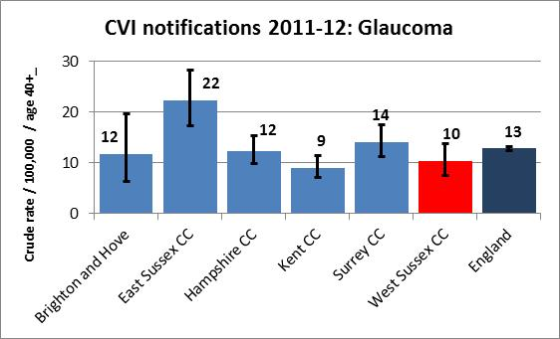
Crude rate of sight loss due to glaucoma in persons aged 40 and over per 100,000 population

Diabetic eye disease - West Sussex is not different from most counties in registering / notifying diabetic eye disease. However, it is significantly worse than Portsmouth UA and East Sussex.

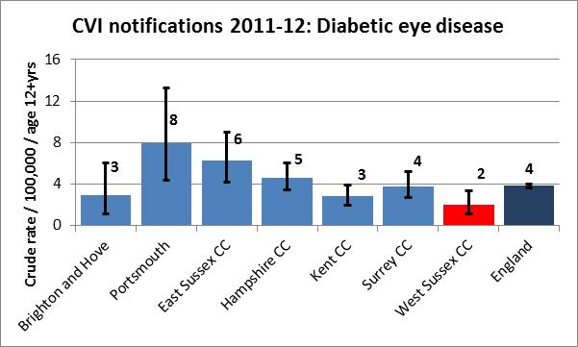
Crude rate of sight loss due to Diabetic Eye Disease in persons aged 12 and over per 100,000 population

Age related macular degeneration - West Sussex is significantly worse at registering / notifying AMD than other counties.

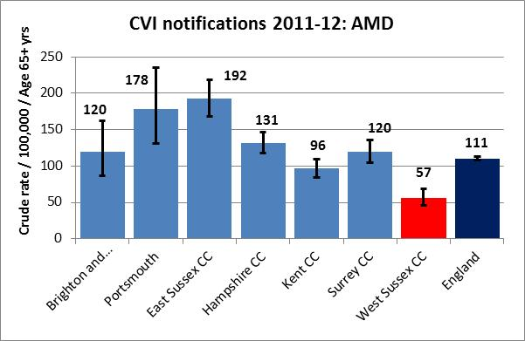
Crude rate of sight loss due to Age Related Macular Degeneration (AMD) in persons aged 65 and over per 100,000 population

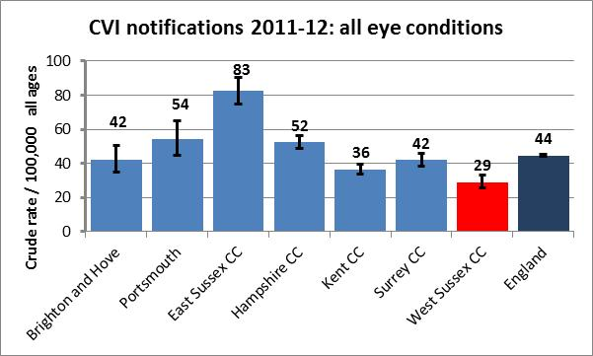
Crude rate of sight loss certifications per 100,000 population

Overall - West Sussex is significantly worse than other counties at registering / notifying eye conditions overall.

Source: Moorfields Eye Hospital
http://www.phoutcomes.info/search/avoidable
http://www.phoutcomes.info/search/avoidable#gid/1/par/E12000008/ati/102/page/9

Registration as a measure of prevalence

It should be noted that CVI registration is voluntary, and there may be people who have sight impairment who do not register; therefore CVI registration should be considered “recorded prevalence”.

Costs

The direct cost to the NHS of vision problems in the UK has been calculated at £40,900 per 1,000 people, with a total cost of £2.14 billion, based on information from 2008 (4).

Direct costs | £ million
Hospital recurrent expenditure | 592.74
Non-admitted expenditure | 507.99
Prescribing expenditure | 158.12
General ophthalmic services (GOS) | 484.04
Expenditure associated with injurious falls | 25.10
Research and development | 13.99
Residential care and community care services | 304.69
Capital and administration | 58.22
Total – Direct costs | 2,144.89
Source: FSUK

The main direct health service costs associated with eye care were:

Primary care
- Ophthalmic - primary ophthalmic services;
- Prescribing and pharmacy - primary care prescribing relating to ophthalmology.

Secondary care
- Inpatient elective and day cases - all admitted patient care ophthalmology activity which takes place in a hospital setting where the admission is either elective or a day case;
- Outpatient - expenditure relating to ophthalmology outpatient attendance or procedures.

The inclusion of indirect costs (employment loss, informal care, etc.) and burden-of-disease costs (DALYs) in the FSUK model led to a ten-fold increase in costs.

Specifcally concerning falls, The RNIB state that:

On average, the estimated medical cost of falls nationally is £269 million. Of the total cost of treating all accidental falls in the UK, 21 per cent was spent on the population with visual impairment (18).

References

- Access Economics 2009. Future Sight Loss UK 1: Economic Impact of Partial Sight and Blindness in the UK adult population. RNIB
- Hospital Episode Statistics: Outpatient, treatment speciality by attendance type: England 2010/2011, Health & Social Care Information Centre http://www.hesonline.nhs.uk/
- FSUK Future Sight Loss UK: An epidemiological and economic model for sight loss in the decade 2010-2020 EpiVision and RNIB http://www.rnib.org.uk/aboutus/research/reports/prevention/pages/fsluk2.aspx
- Department of Health national expenditure data: England level Programme Budgeting data for 2003-04 to 2010-11 http://www.dh.gov.uk/en/Managingyourorganisation/Financeandplanning/Programmebudgeting/DH_075743#_3
- (deleted)
- RNIB and Royal College of Ophthalmologists. June 2011. Don’t turn back the clock: Cataract surgery - the need for patient- centred care.
- (deleted)
- Progress in Retinal Eye Research. 1999 Jan;18(1):121-32. Predisposing factors for chronic angle-closure glaucoma. Salmon JF. Source Oxford Eye Hospital, Radcliffe Infirmary NHS Trust, UK.
- RNIB, March 2004. Unseen Neglect, Isolation and household poverty amongst Older People with Sight Loss.
- Eric Emerson and Janet Robertson, 2011. The Estimated Prevalence of Visual Impairment among People with Learning Disabilities in the UK. RNIB and SeeAbility.
- http://www.rnib.org.uk/eyehealth/lookingafteryoureyes/pages/smoking.aspx
- AMD Alliance International campaign report 2005; Awareness of Age-related Macular Degeneration and Associated Rick Factors
- http://www.rnib.org.uk/eyehealth/lookingafteryoureyes/pages/obesity.aspx
- http://www.stroke.org.uk/media_centre/press_releases/stroke_survivors.html
- Arch Ophthalmol. 1996 May;114(5):545-54. Risk factors for central retinal vein occlusion. The Eye Disease Case-Control Study Group.
- Thomas Pocklington 2007 (Feb), Dementia and Sight Loss
- Tammy Boyce 2011 (August). Falls - costs, numbers and links with visual impairment. RNIB
- Evans, Fletcher and Wormald, 2007 Depression and anxiety in visually impaired older people. Ophthalmology.
- Age UK, 2012. Later Life in the United Kingdom.
- HSCIC. Registered Blind and Partially Sighted People, Year ending 31 March 2011, England https://catalogue.ic.nhs.uk/publications/social-care/vulnerable-adults/peop-regi-blin-part-sigh-eng-11/peop-regi-blin-part-sigh-eng-11-rep.pdf
- Charles, N. (2006) 'The number of people in the UK with a visual impairment: the use of research evidence and official statistics to estimate and describe the size of the visually impaired population', Nigel Charles, RNIB, July 2006
- Scuffham P, Chaplin S, Legood R (2003) Incidence and costs of unintentional falls in older people in the United Kingdom. J Epidemiol Community Health, 57:740–4.
- Gordon D, Parker R, Loughran F, Heslop P: Disabled Children in Britain: A Re-Analysis of the OPCS Disability Surveys. London: The Stationery Office; 2000.
- Rahi JS, Cable N, British Childhood Visual Impairment Study G. (2003). Severe visual impairment and blindness in children in the UK. Lancet 362(9393):1359-65.
- Thomas Coram Research Unit & Institute of Education, University of London. Disabled Children: Numbers, Characteristics and Local Service Provision. Report to DCSF, 2008

Uncorrected refractive error is, however, a problem in the developing world. WHO estimates that 153 million people worldwide live with visual impairment due to uncorrected refractive errors. http://www.who.int/features/qa/45/en/
This leads to difficulties in driving at night – glare from traffic lights and lack of discernment of low-contrast, such as the line between kerb and road.
Tammy Boyce, Falls - costs, numbers and links with visual impairment, August 2011 RNIB http://www.rnib.org.uk/aboutus/research/reports/complexneeds/pages/falls_costs.aspx
This information may be available via the NHS network, but use of this network was not feasible at the time of writing.
See http://www.rnib.org.uk/LIVINGWITHSIGHTLOSS/YOURMONEY/BENEFITS/Pages/benefits.aspx and https://www.gov.uk/dla-disability-living-allowance-benefit/what-youll-get
This should still be checked, just in case the WSx register has been enhanced with extra local data.
File: peop-regi-blin-part-sigh-eng-11-coun-tab

